Brownsville Independent School District

School-Parent-Student Compact
2020-2021
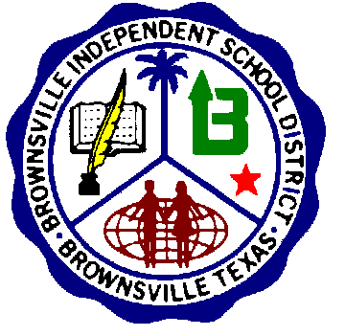
Paredes Elementary
SCHOOL |  | PARENT |  | STUDENT
In recognition that it is the school's responsibility to provide a high-quality curriculum and instruction in a supportive and effective learning environment, the school agrees to: |  | In recognition that it is the responsibility of parents to support their children's learning, the parents of students attending Paredes Elementary School agree to: |  | In recognition that the students have the ultimate responsibility (privilege) of learning, the student agrees to:
1.-Provide a high quality curriculum in a supportive and effective environment that enables the children served to meet the State’s Student Performance Standards.  2.-Discuss with parents their responsibilities for supporting improved achievement.  3.-Inform parents and students of the purpose of the curriculum and district timelines, students’ performance standards, and the instruction the school will provide to enable students to achieve the state standard.  4.-Schedule Parent/Teacher conferences.  5.-Provide opportunities for encouraging parents to volunteer.  6.-Train teachers and other staff on the latest instructional strategies and methodologies to maintain and improve a positive learning environment in the school. |  | 1.-Ensure that their children attend school and be on time every day.  2.-Teach and model respect and responsibility at all times.  3.-Ensure that their children do their homework.  4.-Encourage positive use of their children’s spare time.  5.-Participate in family reading in order to foster a love for reading.  6.-Read at home for two purposes; to increase their knowledge, and to be an example for them.  7.-Limit the use of electronic devices used by children, such as, TV, and video games.  8.-Support their children in the classroom.  9.-Attend Parent/Teacher conferences and the Parental Involvement activities/meetings.  10.-Provide appropriate nourishment and rest for the physical well-being of their children. |  | 1.-Be responsible for his / her own learning and behavior.  2.-Attend school and be on time every day.  3.-Be alert and pay attention in class.  4.-Encourage other student who need help.  5.-Take homework assignments home, complete them, and return them to the teacher on time.  6.-Take pride in his/her school, individual work, and personal appearance.  7.-Display respect for himself / herself, school staff, and others at all times.  8.-Participate in family reading.
Teacher Signature / Date |  | Parent Signature / Date |  | Student Signature / Date
Date of Parent-Teacher Conference: _______________________

BISD does not discriminate on the basis of race, color, national origin, sex, religion, age, disability or genetic information in employment
or provision of services, programs or activities

